**Day 3**

**USE Northwind from Kaggle:**

1. Update the categoryName From “Beverages” to "Drinks" in the categories table.

**Query**:

**update categories**

**set categoryname ='Drinks'**

**where categoryname ='Beverages';**

**Screenshot**:

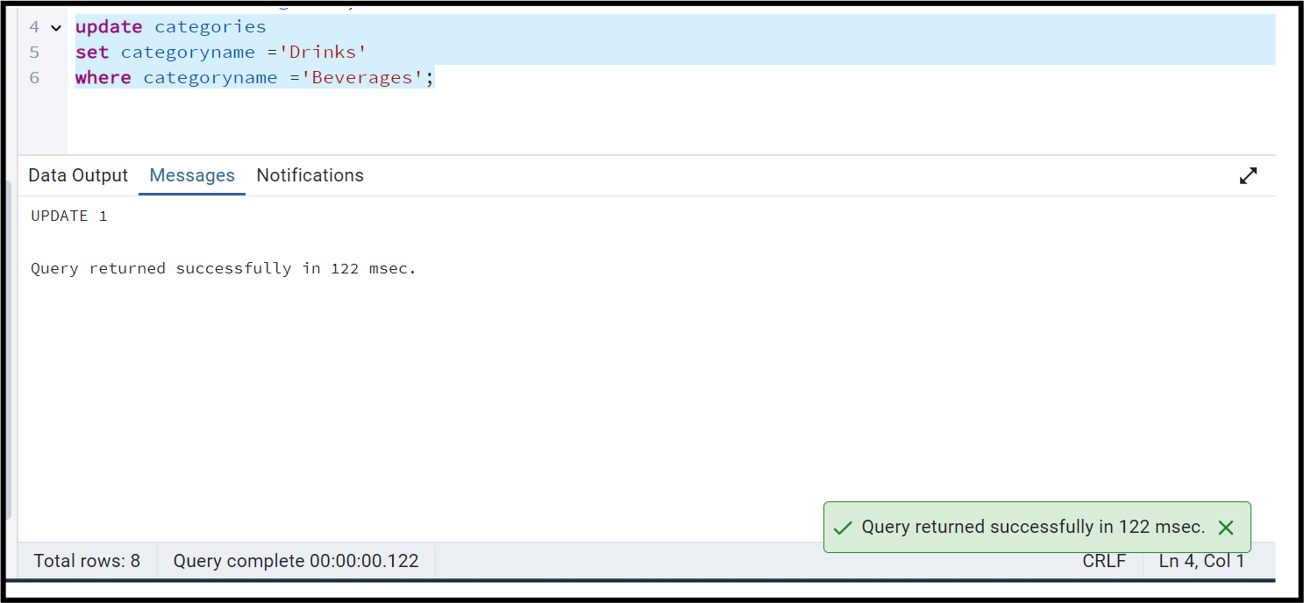

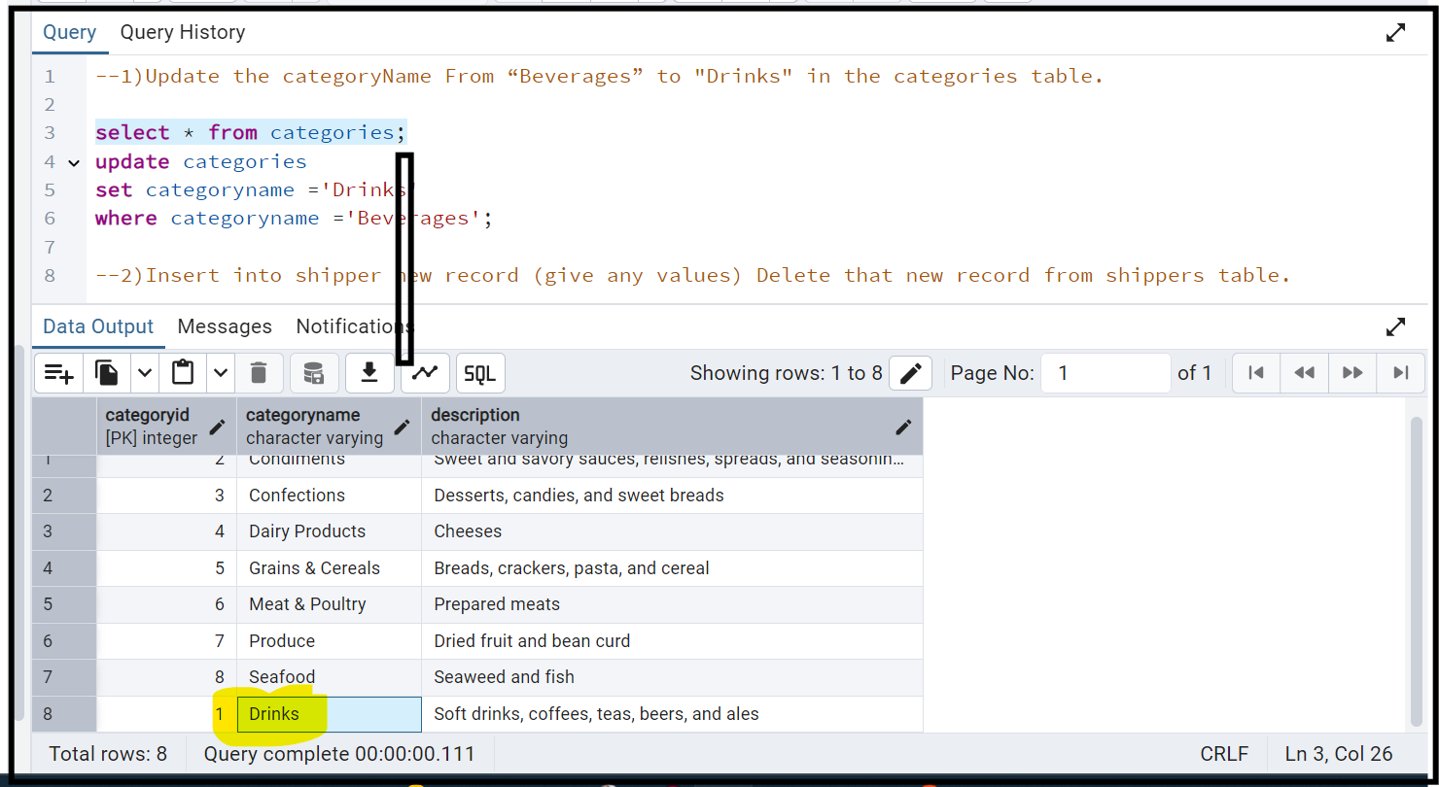

1. Insert into shipper new record (give any values) Delete that new record from shippers table.

**Query**:

**insert into shippers**

**(shipperid, companyname)**

**values(4,'Indian Shipping through post');**

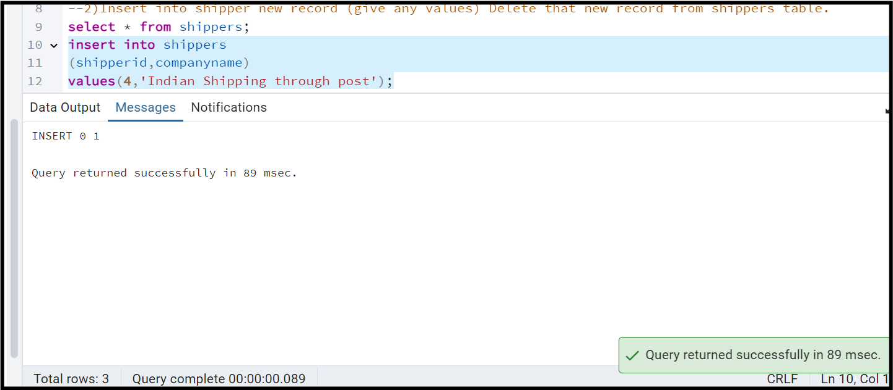

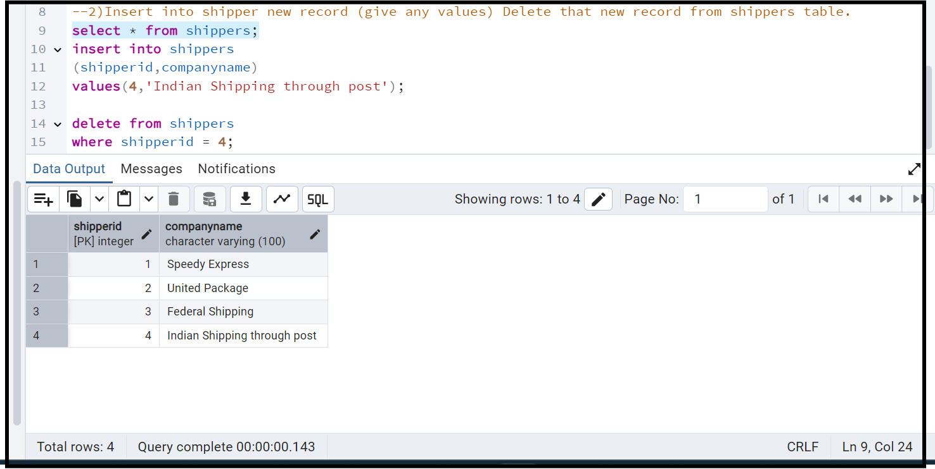

To delete:

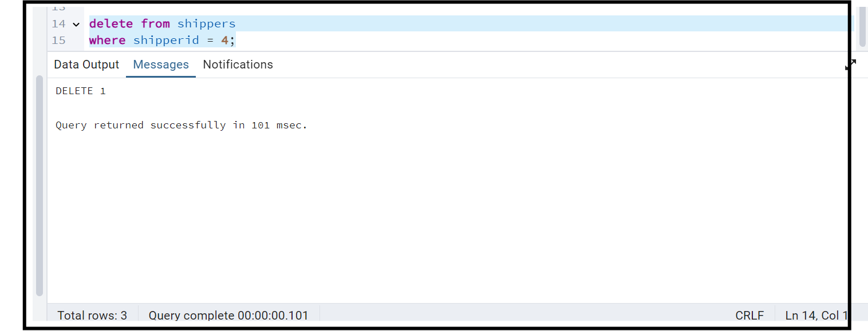

After delete:

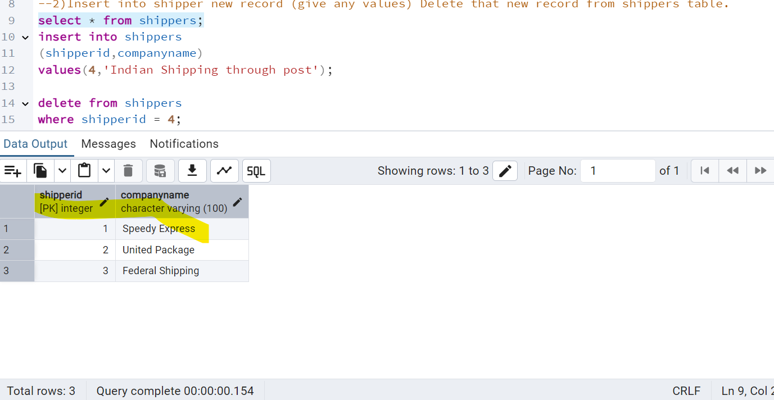

3) Update categoryID=1 to categoryID=1001. Make sure related products update their categoryID too. Display the both category and products table to show the cascade.

Delete the categoryID= “3” from categories. Verify that the corresponding records are deleted automatically from products.

(HINT: Alter the foreign key on products(categoryID) to add ON UPDATE CASCADE, ON DELETE CASCADE)

**Ans**:

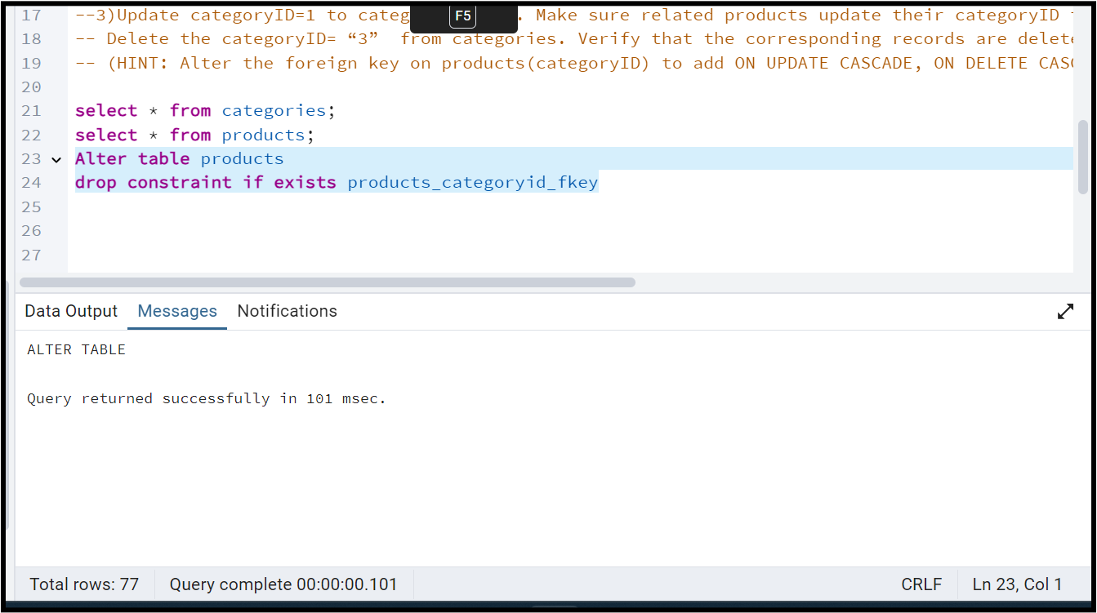

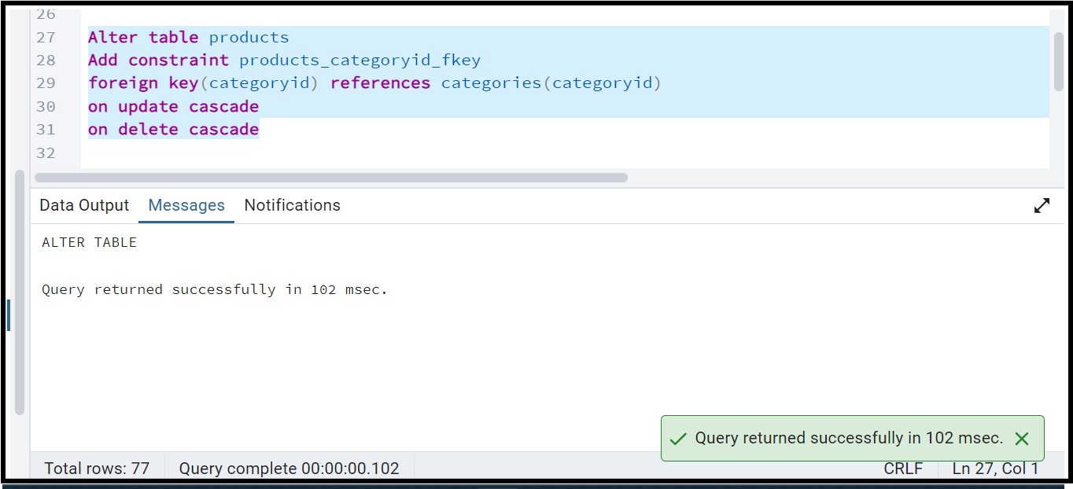

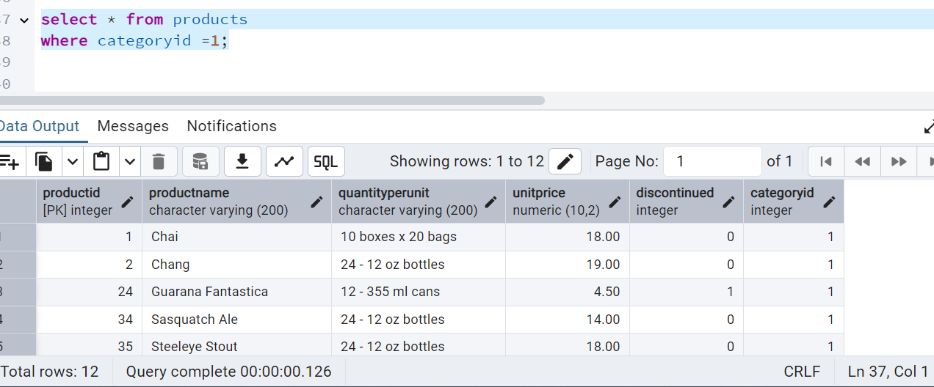

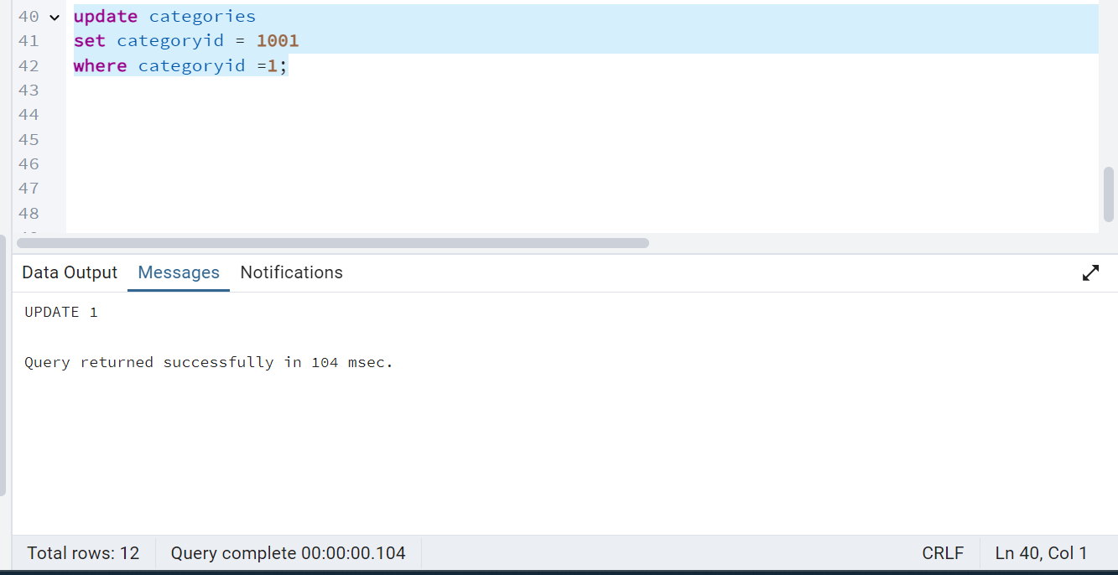

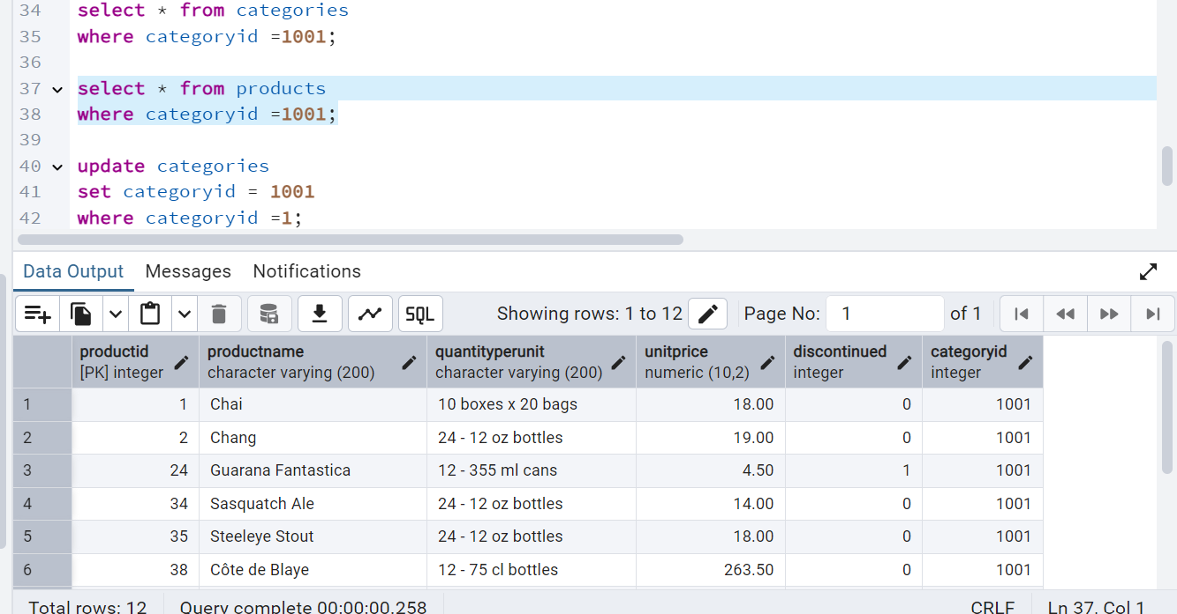

Before delete :

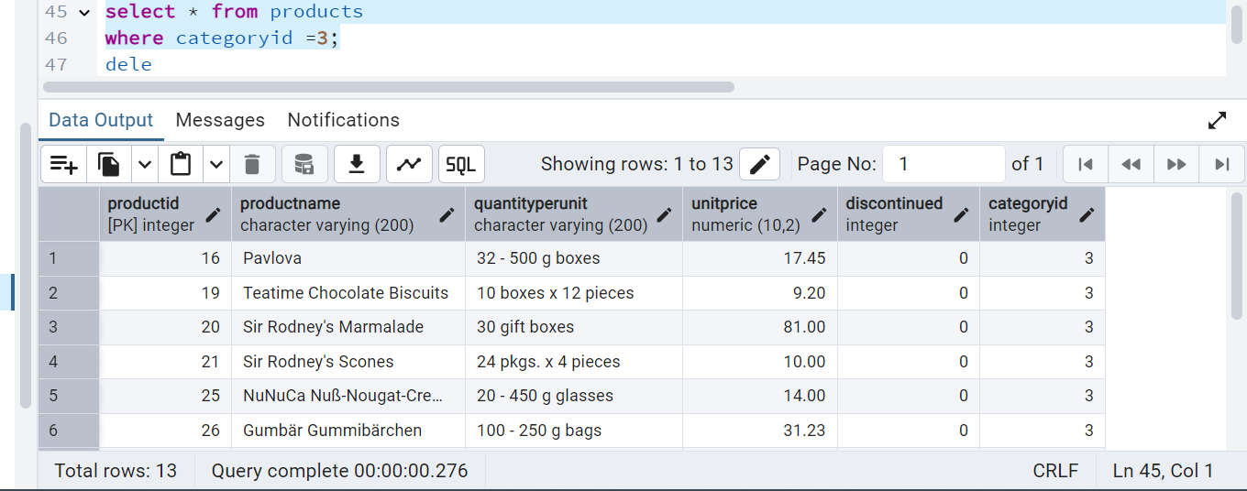

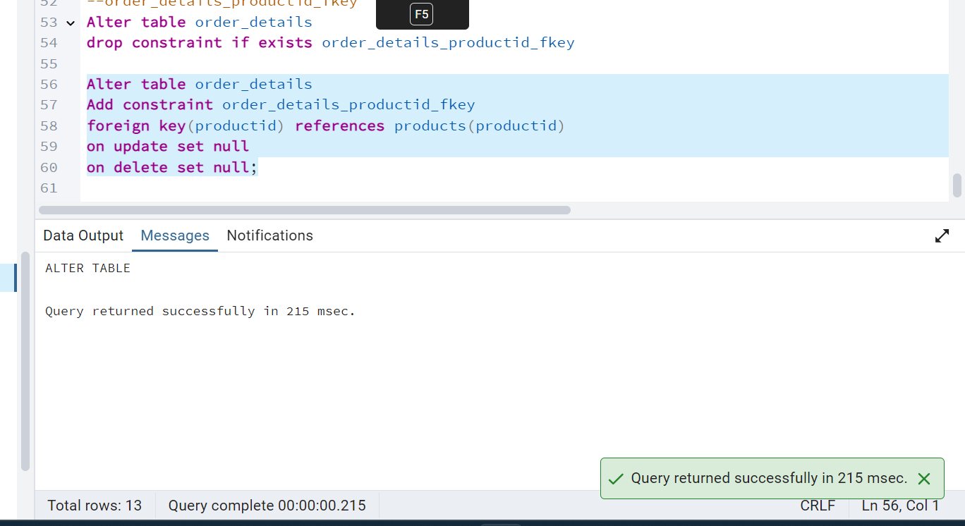

Now able to delete category table with category id =3

delete from categories

where categoryid =3;

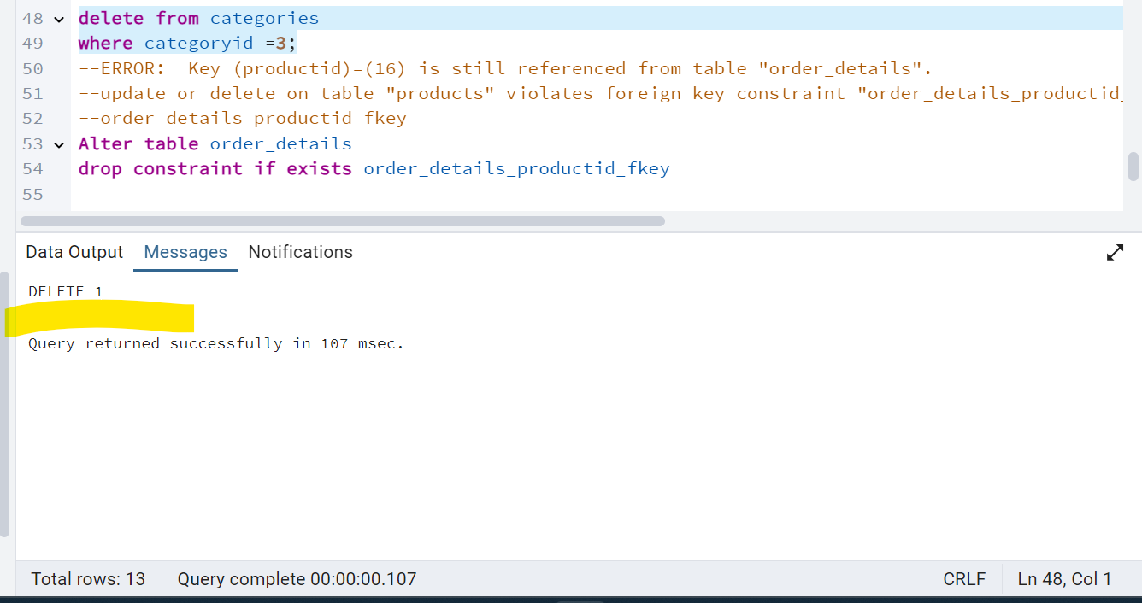

Product table

After deletion:

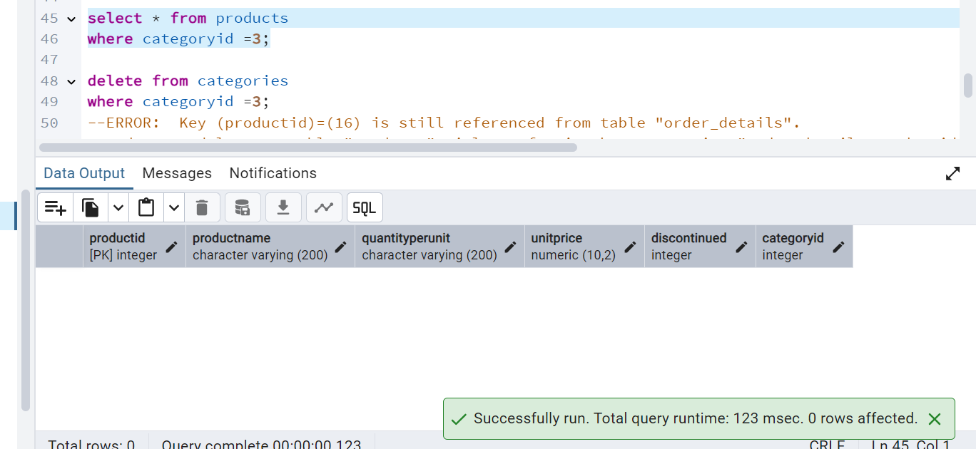

4) Delete the customer = “VINET” from customers. Corresponding customers in orders table should be set to null (HINT: Alter the foreign key on orders(customerID) to use ON DELETE SET NULL)

Customer table:

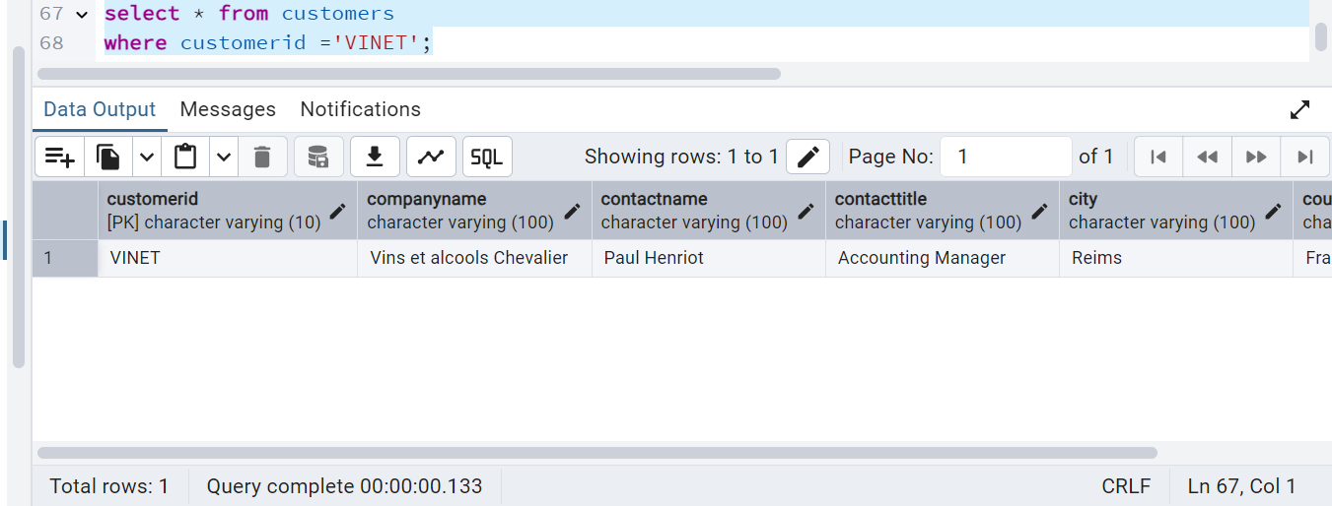

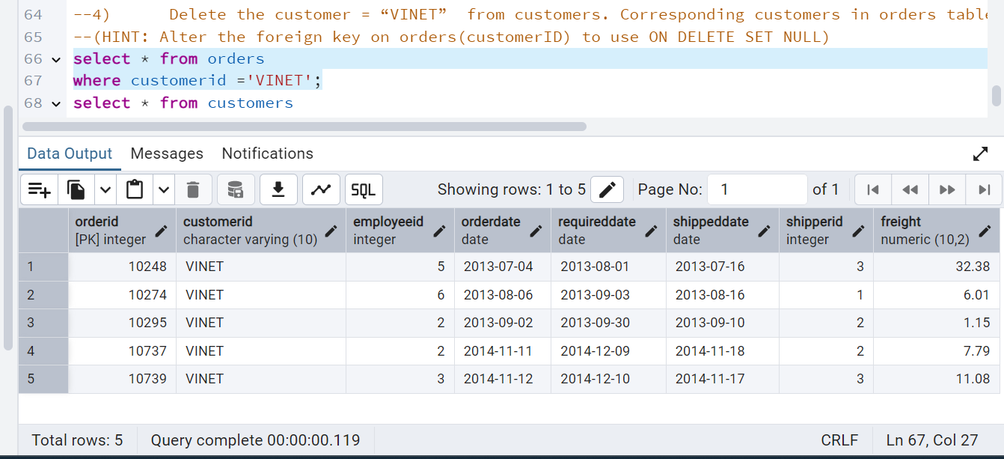

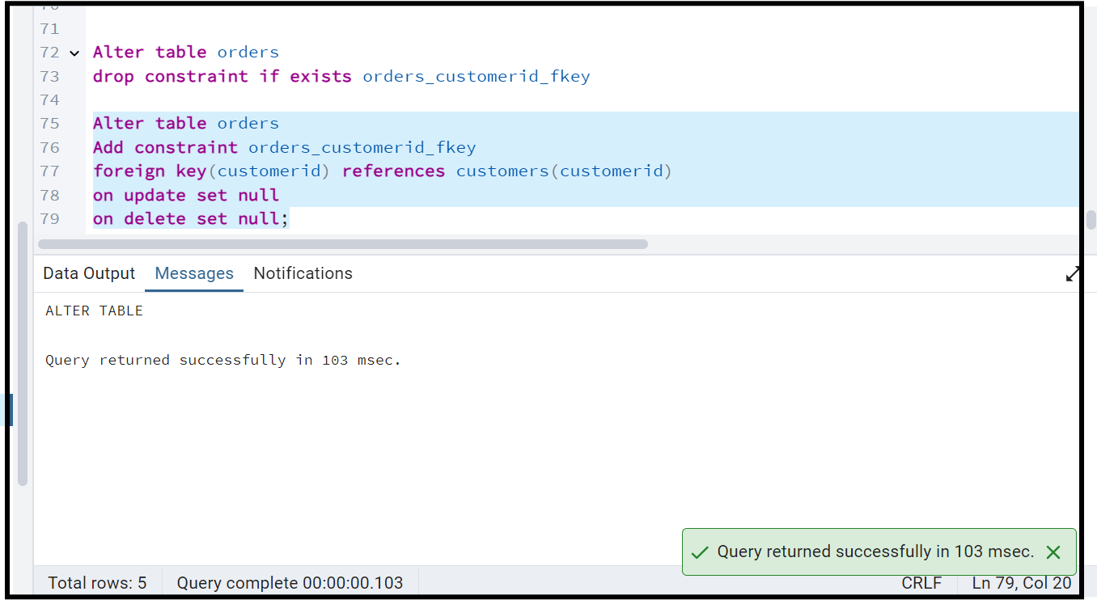

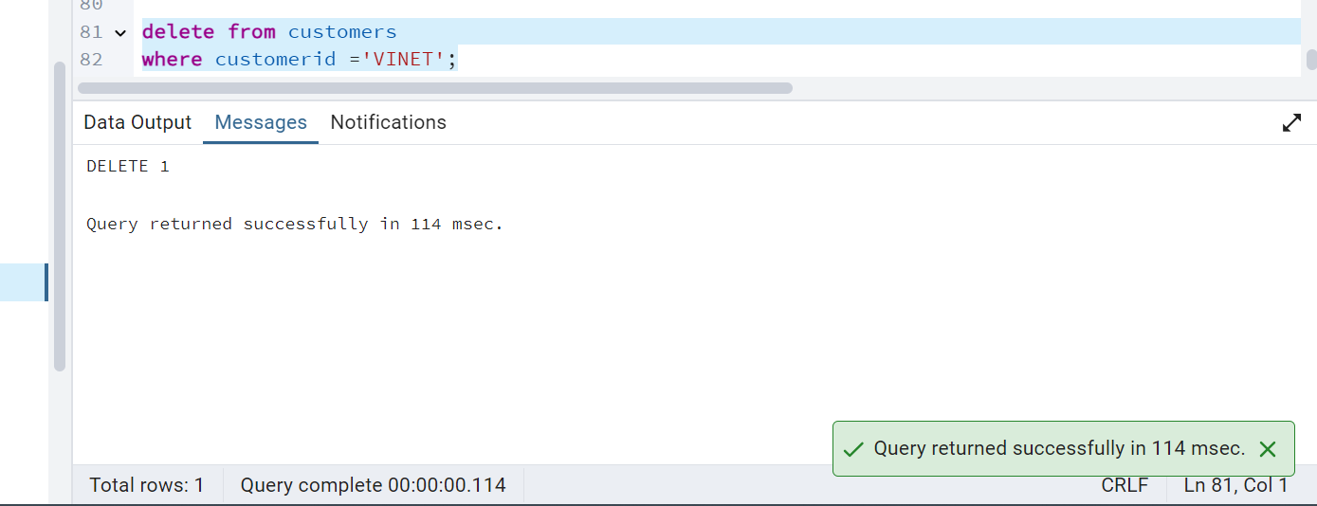

After delete on Customer , Product table customerid is set to null

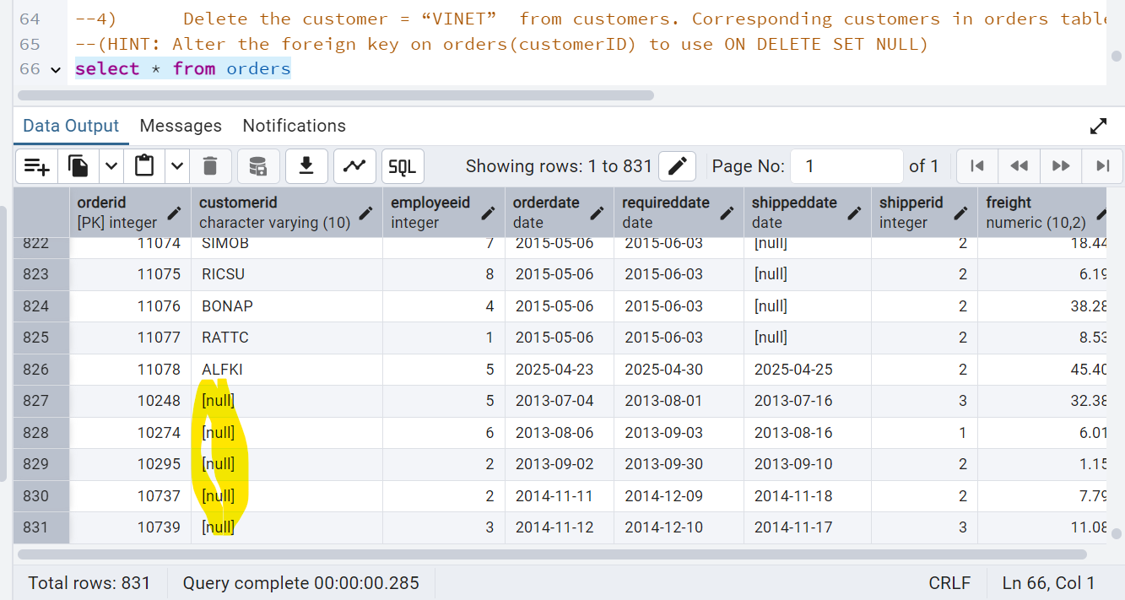

5) Insert the following data to Products using UPSERT:

product_id = 100, product_name = Wheat bread, quantityperunit=1,unitprice = 13, discontinued = 0, categoryID=3

product_id = 101, product_name = White bread, quantityperunit=5 boxes,unitprice = 13, discontinued = 0, categoryID=3

product_id = 100, product_name = Wheat bread, quantityperunit=10 boxes,unitprice = 13, discontinued = 0, categoryID=3

(this should update the quantityperunit for product_id = 100)

**Query:**

**insert into products(**

**productid,**

**productname,**

**quantityperunit,**

**unitprice,**

**discontinued,**

**categoryid)**

**values**

**(100, 'Wheat bread', '1', 13, 0, 1001),**

**(101, 'White bread', '5 boxes', 13, 0, 1001)**

**on conflict(productid)**

**do update set**

**productname = excluded.productname,**

**quantityperunit = EXCLUDED.quantityperunit,**

**unitprice = EXCLUDED.unitprice,**

**discontinued = EXCLUDED.discontinued,**

**categoryID = EXCLUDED.categoryid;**

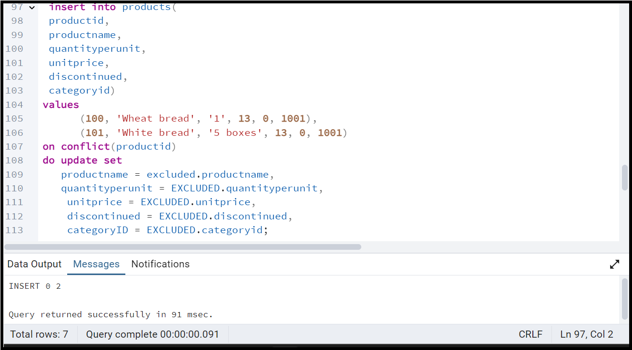

After Insert:

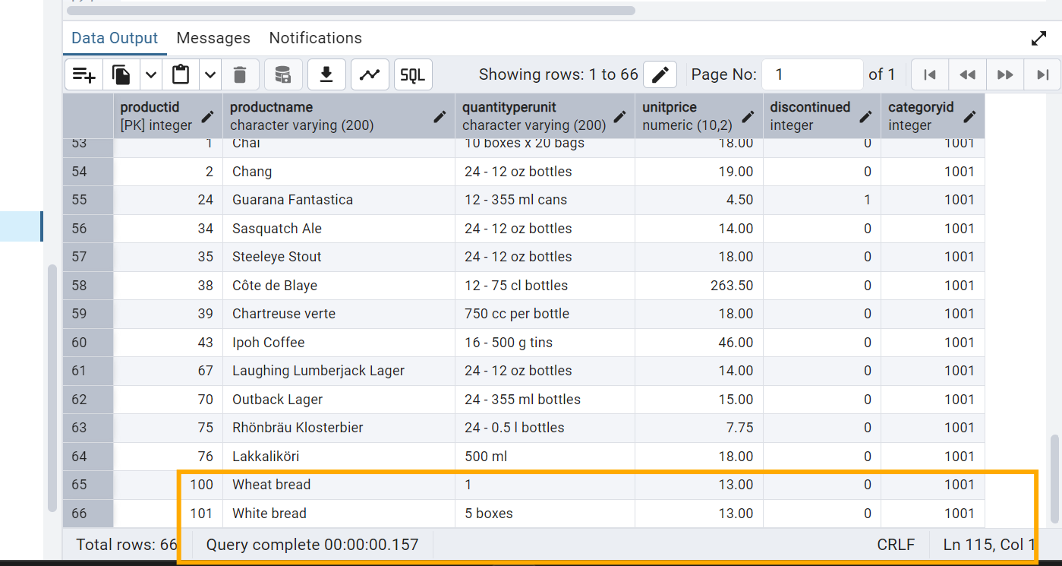

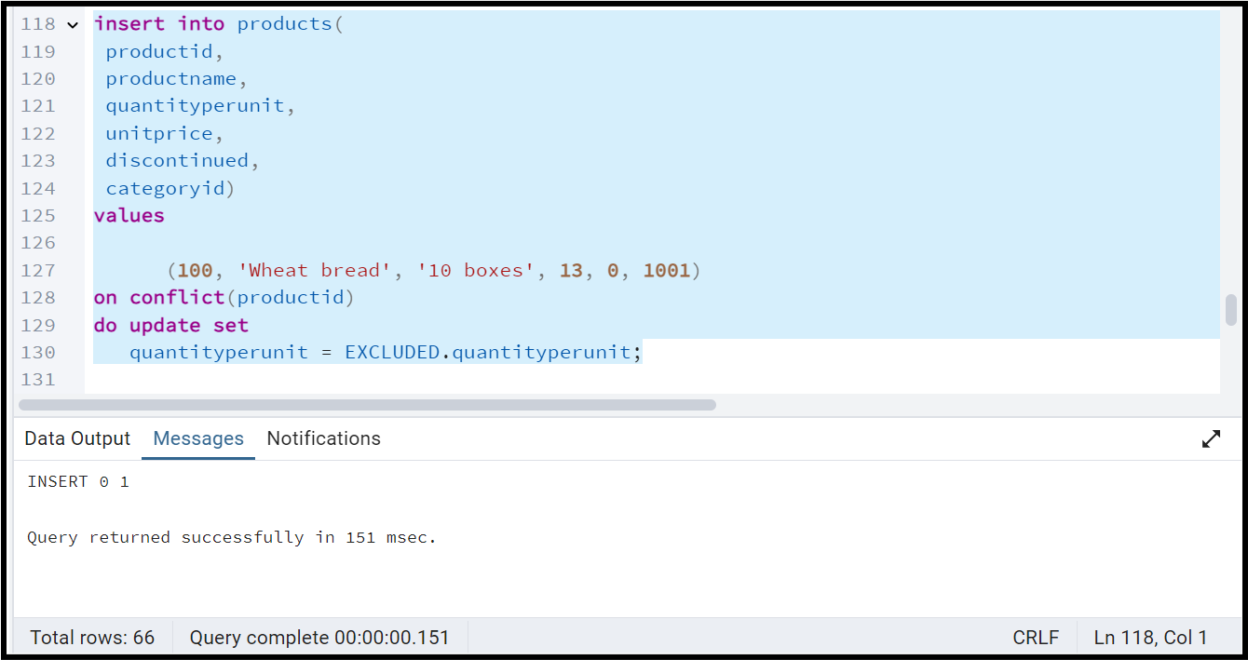

After Update:

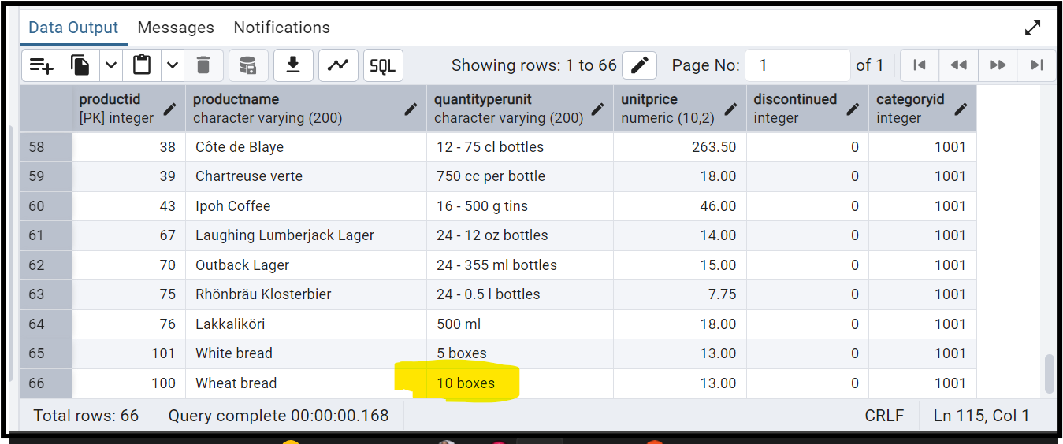

6) Write a **MERGE query**:

Create **temp table with name:**  ‘updated_products’ and insert values as below:

|  |  |  |  |  |  |
| --- | --- | --- | --- | --- | --- |
| productID | productName | quantityPerUnit | unitPrice | discontinued | categoryID |
| 100 | Wheat bread | 10 | 20 | 1 | 3 |
| 101 | White bread | 5 boxes | 19.99 | 0 | 3 |
| 102 | Midnight Mango Fizz | 24 - 12 oz bottles | 19 | 0 | 1 |
| 103 | Savory Fire Sauce | 12 - 550 ml bottles | 10 | 0 | 2 |

* Update the price and discontinued status for from below table ‘updated_products’ only if there are matching products and updated_products .discontinued =0
* If there are matching products and updated_products .discontinued =1 then delete

* Insert any new products from updated_products that don’t exist in products only if updated_products .discontinued =0.

Ans:

**Query**:

**MERGE into products p**

**using (**

**VALUES**

**(100, 'Wheat bread', '10', 20, 1, 1001),**

**(101, 'White bread', '5 boxes', 19.99, 0, 1001),**

**(102, 'Midnight Mango Fizz', '24-12 oz bottles', 19, 0, 4),**

**(103, 'Savory Fire Sauce', '12-550 ml bottles', 10, 0, 2)**

**) AS updated_products(productid, productname,quantityperunit,unitprice,discontinued,categoryid)**

**on p.productid =updated_products.productid**

**when matched and updated_products .discontinued =0 then**

**update set**

**unitprice = updated_products.unitprice,**

**discontinued = updated_products.discontinued**

**when matched and updated_products .discontinued =1 then**

**delete**

**when not matched and updated_products .discontinued =0 then**

**insert(productid,productname,quantityperunit,unitprice,discontinued,categoryid)**

**values(updated_products.productid,**

**updated_products.productname,updated_products.quantityperunit,**

**updated_products.unitprice,**

**updated_products.discontinued,updated_products.categoryid)**

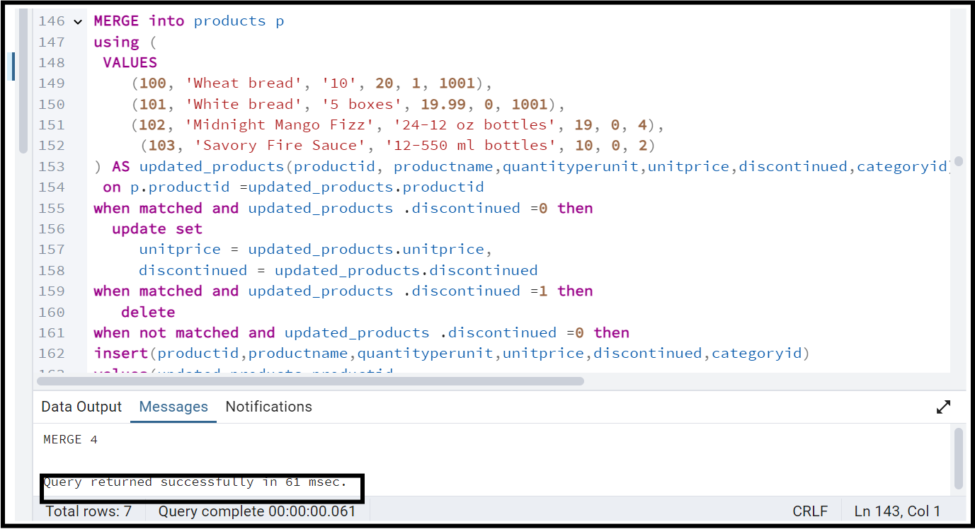

After above query executed, Product table

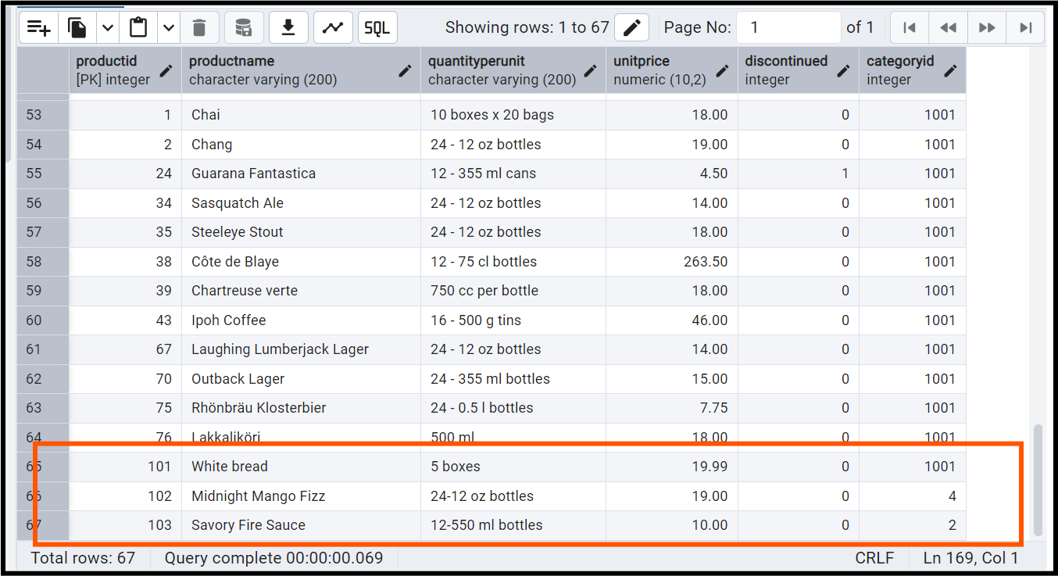

**USE NEW Northwind DB:**

7) List all orders with employee full names. (Inner join)

**Query**:

**select e.employee_id,e.first_name || ' '||e.last_name as Full_Name,**

**e.title, o.order_id,o.customer_id,o.order_date,o.required_date,o.shipped_date**

**from employees e**

**inner join orders o**

**on e.employee_id = o.employee_id;**

